Team Kinetic Robotics

Technical Report

Preface

由于我们队伍的经费问题和学校流程问题，导致目前为止还没有拿到ICRA官方机器人，以至于使用来自RoboMaster比赛的赠车机器人来，所以如果裁判系统配置一则是技术报告评审的必要条件，那么可以提前结束阅读了，这里深感抱歉。(specifically apologise) (TODO: use the UK style)

这篇技术报告共两大部分，分别为硬件和软件部分。

硬件部分分为3个部分，分别为机械结构，传感器，计算设备。主要描述了机器人基础上的改进说明，传感器布局，选型理由及其参数等等。

软件部分则有6个部分，分别为定位，运动规划，自动识别，自动打击，自动补给，智能决策。主要描述了使用的算法，算法的性能，遇到的问题，提出可能改进的方案。

Contents

Pre-content 0

**1. Hardware** 0

**1.1 Mechanical Structure** 0

**1.1.1 Chassis** 0

**1.1.2 Gimbal** 1

**1.2 Sensor Module** 1

**1.2.1 Camera** 1

**1.2.2 LiDAR** 2

**1.2.3 Ultrasonic sensor** 3

**1.3 Computing Device** 3

**2. Software** 4

**2.1 Localization** 4

**2.2 Motion Planning** 4

**2.3 Automatic Detection** 5

**2.4 Fire Automation** 5

**2.5 Automatic Supply** 5

**2.6 Intelligent Decision** 5

# **1. Hardware**

## **1.1 Mechanical Structure**

原有的机器人机械结构大致不变，我们在此基础上添加了一个雷达底座，一个摄像头底座。并打算在将来改进弹仓尺寸，增加弹仓口面积，以提高自动补给的容错率。

雷达底座安装于电池座前面，距离机器人坐标中心(x, y, z, r, p, y)

摄像头底座安装于云台Pitch轴电机上部，距离机器人坐标中心。

Figure 1，figure 2

Todo：

底盘主控板放置于底盘右侧。

Tx2放置于底盘右侧，由底盘主控板分电进行供电。

Usb hub放置于底盘右侧。

Figure 3

## **1.2 Sensor Module**

### **1.2.1 Single Gyro**

由于目前暂时使用RM官方赠车来测试，故缺少陀螺仪模块，通过网络搜素，一款高精度的单轴陀螺仪往往需要几千块的RMB，由于经费紧缺，故优先选择性价比高的单轴陀螺仪模块。通过搜索，查找，最终锁定了一款ADI高精度单轴陀螺仪，其售价低于千元，性能据称可以达到10分钟低于2度的变化。

通过实测，获取/odom topic 的信息可以统计，…分钟…度的变化，精度足以满足比赛要求。

Figure 4

### **1.2.2 Camera**

Based on our previous experiences, it is highly important to choose a camera that can reduce motion blur. In addition, the parameter adjustment is also one of the necessary functions, which represents the convenience.

Compare and contrast with previous experience, monocular camera, binocular camera these two cameras are included in our consideration.

For monocular camera,

Todo : 工业摄像头， 参数, 算法设置多少，强调后面算法提到

For binocular camera, the two most important factors we consider are depth sensing and motion tracking. The binocular camera can easily detect the distance between the enemy robot, and then shoot. As a matter of fact, we consider using binocular camera Intel RealSense after the basic implementation of monocular camera:

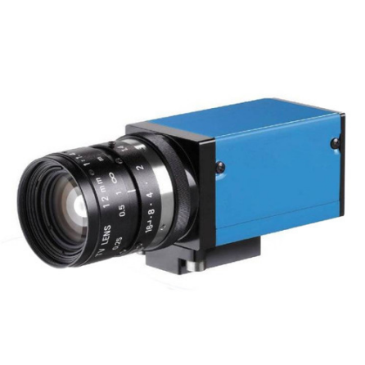

Monocular Camera (right) Intel RealSense D415 (left)

Figure 5 (detection img)， figure 6 (depth img)

As mentioned above we finally chose a camera that supports USB3.0, parameters adjustment and high frame rate for motion blur reduction. The resolution of the camera is not that satisfactory, with only 640x360 resolution rate, but the competition does not require the resolution rate that much. It is quite enough to get image features such as amour light bar on this resolution rate. In short, the camera we have chosen is quite enough for the competition.

### **1.2.3 LiDAR**

LiDAR is a critical device for localization and navigation.

Since the LiDAR works like shine a small light at a surface and measure the time it takes to return to its source, Therefore the adaptive scanning frequency and range sample frequency would be the high priorities for choosing a LiDAR.

The LiDAR we are going to use is the G4 LiDAR which developed by YDLiDAR CO, with range sample frequency about 9000hz, scanning range around 16m and maximum 12Hz adaptive scanning frequency. The reason why we are choosing this LiDAR is that it has the highest adaptive scanning frequency and range sample frequency among the same type of product, and the price is also quite reasonable.

Todo：放扫描图，最远距离。。。figure 7

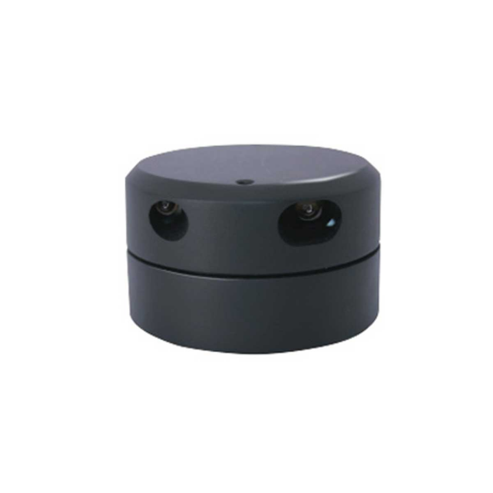

LiDAR

## **1.3 Computing Device**

计算设备我们有两种选择，第一个是Nvidia jetson tx2 ，第二个是IPC，基于多个原因，最终我们选择了第一个方案。

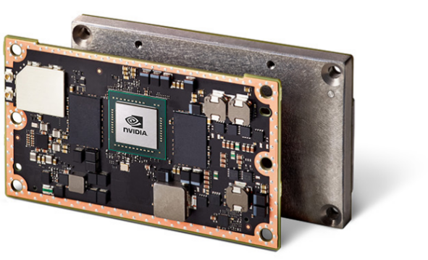First, Jetson TX2 is a tiny little board built around Nvidia Pascal-family GPU with 256 CUDA cores which means faster speed on matrix multiplication. The CPU complex consists of a Quad-core A57 ARM processor connected to a dual core Denver processor, way slower than the I7, but it is ok to use.

|  |  |
| --- | --- |
|  | Nvidia Jetson TX2 |
| GPU | Nvidia Pascal, 256 CUDA cores |
| CPU | HMP Dual Denver 2/2 MB L2 |
|  | Quad ARM A57.2 MB L2 |
| Memory | 8 GB 128bit LPDDR4 59.7GB/s |
| Data Storage | 32GB eMMC |

Jetson TX2

第二，我们拥有工控机是没有GPU处理核心的（GPU…）。

第三，工控机体积大，功耗高，需要外加供电设备，但是没空间…

# **2. Software**

## **2.1 Localization**

1、使用ACML算法，ACML算法是什么

2、figure8初始定位精度怎么样，刷新时间？figure9，10，11随机定位精度怎么样，刷新时间？对角线来回1次精度怎么样？3次？5次？测量离墙壁x，y距离

3、总结

## **2.2 Motion Planning**

1、采用避障传感器为雷达，过滤多少度的数据。Figure 12， 13

2、全局路径规划采用A*，规划频率。Figure 13

3、局部路径规划采用TEB，Figure 14，规划频率，最大运动速度，避障能力（见视频）

## **2.3 Detection**

Detection is mainly reflected in the armor detection in the challenge.

1、识别装甲板，描述算法figure 15～20

2、获取敌人大概方位和距离

Map来获取敌人，算法：

在AMCL里面，将scan points里面与障碍点匹配（符合一定范围内）的point 设置为false，剩下的设置为true，设置两个KNN点，邻近两个点集，由于在ICRA的赛场上机器人显得十分突兀，且和墙壁有一段距离，故knn迭代一次两次即可确定机器人的粗略位置（迭代多次反而不好），同时即可发现敌人方便决策，也可运用于自动打击的距离误差补偿上。

## **2.4 Fire Automation**

1、

2、在自己的机器人上测试官方的demo时发现两种情况，

## **2.5 Automatic Supply**

1、雷达ACML定位，补给，发送指令，描述误差，精度。

2、当开启弹仓拨轮后，枪管的限位开关没有发现有子弹经过3秒，判断自己为没有子弹，再根据敌人大概位置信息，判断是否进行补给。

## **2.6 Intelligent Decision**

1、pygame，gym（A3C，说一下SC2，再放图 （说一下单机决策，因为没有两台机

2、决策树